**Variable and Datatype in Java**

1. [Variable](http://www.javatpoint.com/variable-datatype#variable)
2. [Types of Variable](http://www.javatpoint.com/variable-datatype#typesofvariable)
3. [Data Types in Java](http://www.javatpoint.com/variable-datatype#datatype)

|  |
| --- |
| In this page, we will learn about the variable and java data types. Variable is a name of memory location. There are three types of variables: local, instance and static. There are two types of datatypes in java, primitive and non-primitive. |

**Variable**

Variable is name of reserved area allocated in memory.

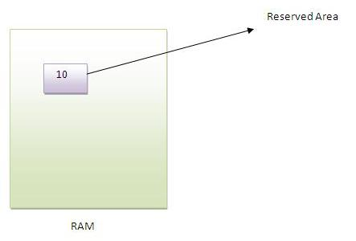

1. int data=50;//Here data is variable

**Types of Variable**

|  |
| --- |
| There are three types of variables in java   * local variable * instance variable * static variable |

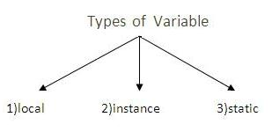

**Local Variable**

|  |
| --- |
| A variable that is declared inside the method is called local variable. |

**Instance Variable**

|  |
| --- |
| A variable that is declared inside the class but outside the method is called instance variable . It is not declared as static. |

**Static variable**

|  |
| --- |
| A variable that is declared as static is called static variable. It cannot be local. |

|  |
| --- |
| We will have detailed learning of these variables in next chapters. |

**Example to understand the types of variables**

1. class A{
2. int data=50;//instance variable
3. static int m=100;//static variable
4. void method(){
5. int n=90;//local variable
6. }
7. }//end of class

**Data Types in Java**

|  |
| --- |
| In java, there are two types of data types   * primitive data types * non-primitive data types |

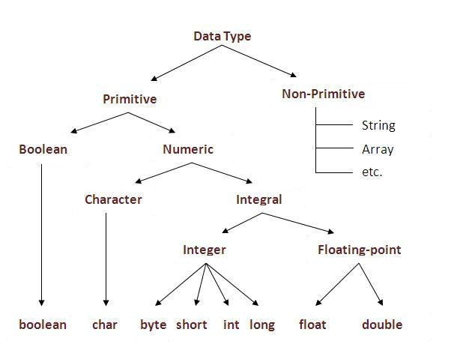

|  |  |  |
| --- | --- | --- |
| **Data Type** | **Default Value** | **Default size** |
| boolean | false | 1 bit |
| char | '\u0000' | 2 byte |
| byte | 0 | 1 byte |
| short | 0 | 2 byte |
| int | 0 | 4 byte |
| long | 0L | 8 byte |
| float | 0.0f | 4 byte |
| double | 0.0d | 8 byte |

**Why char uses 2 byte in java and what is \u0000 ?**

because java uses unicode system rather than ASCII code system. \u0000 is the lowest range of unicode system.To get detail about Unicode see below.

Next Topic[Unicode System In Java](http://www.javatpoint.com/unicode-system-in-java)